**Nitin Chakravarthy Gummidela**

**427006656**

**CSCE 689 - Computational Photography:**

**Assignment 4:**

In this assignment we were given 4 different sets of images with different exposures. Two sets of images were used to calibrate the camera response function for two different cameras and all the images were recreated using the corresponding response functions. In this process local and global tone mapping were used. Matlab’s inbuilt “localtomemal()” function was used for local tonemapping. And global tone mapping was perfomed by calculating (irradiance/ I + irradiance). Also multiple alpha values were used to see which would give the best reconstruction of the HDR image.

The camera response functions were calculated and stored in matrices named ‘cameracalib0.mat’ and ‘cameracalib1.mat’, which correspond to ‘0_Calib_chapel’ and ‘1_Calib_Office’ set of images. Then first ‘cameracalib0.mat’ was used to reconstruct the image of the Chapel and the ‘cameracalib1.mat’ was used to reconstruct the remaining three sets of images which correspond to office, bicycles and a statue. Further, the camera response functions were used in the in the reverse order to notice differences.

Results:

The camera response functions for the two sets of images are as follows:

1. Chapel:

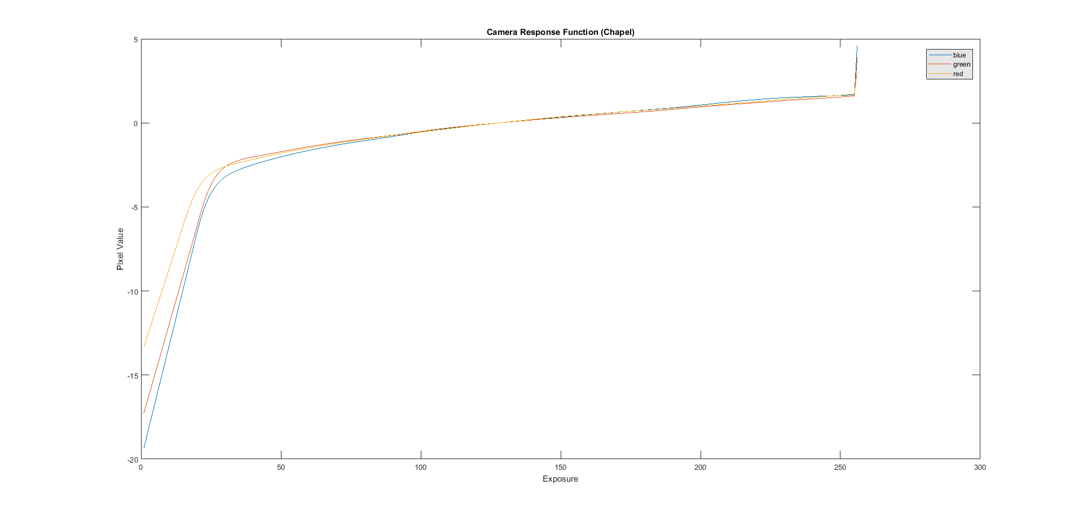

1. Office:

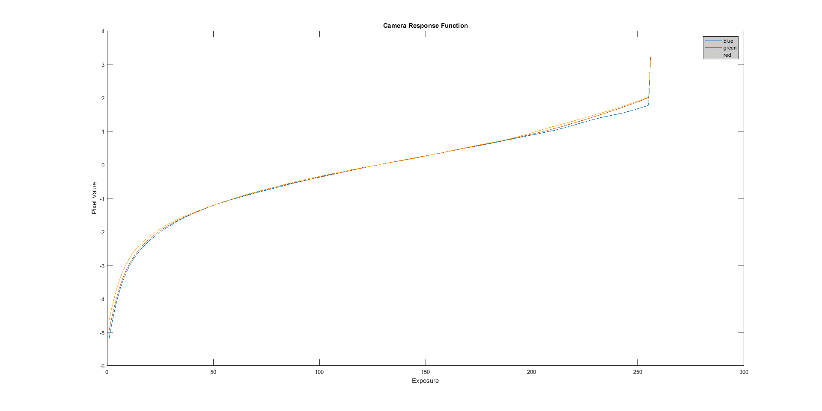

**Reconstruction of HDR Chapel image using camera response function from the chapel set of images:**

For, tone-mapping various alpha values were used and the results are as follows:

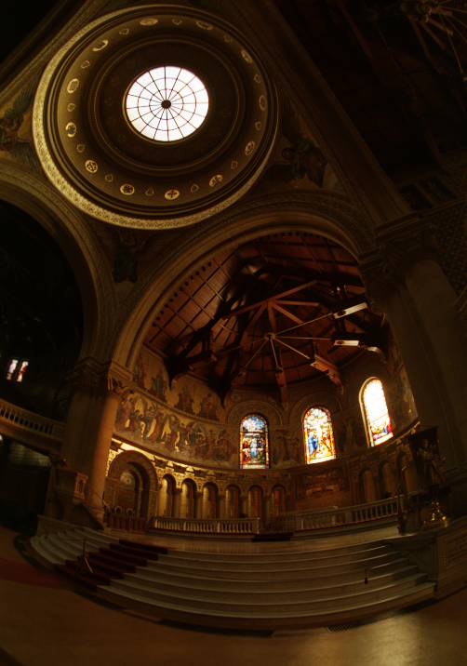

Alpha = 1

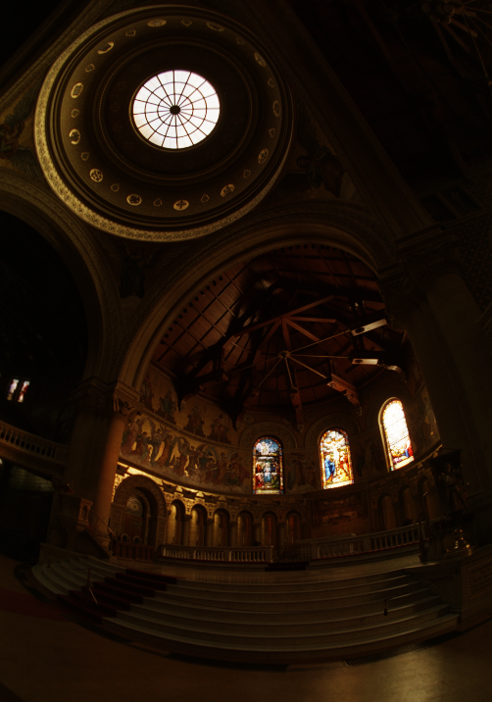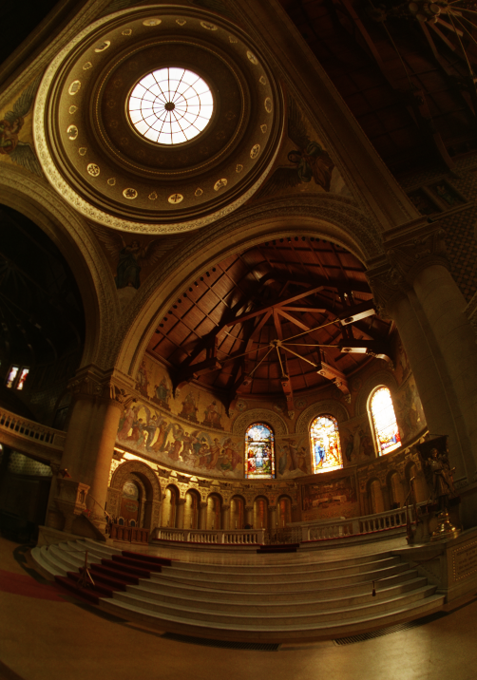

Alpha = 1.5

Alpha = 0.5

Alpha = 4

Alpha = 5

Alpha = 2

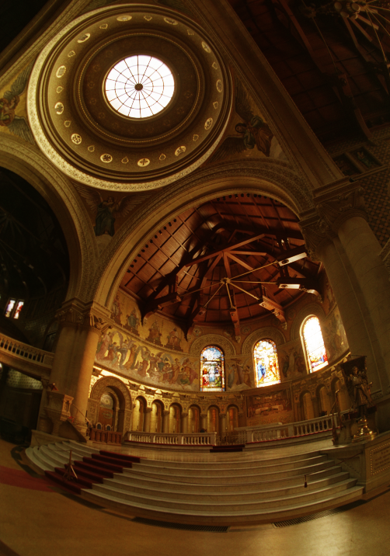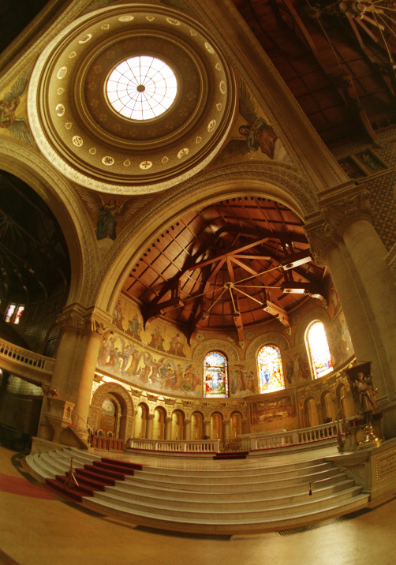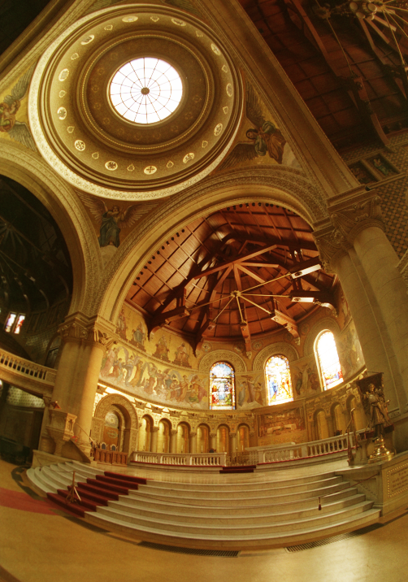

From the above images we can see that at alpha between 1.5-5 there is a good amount of details in both the highly illuminated and low illuminated areas.

The local tone mapped image is as follows:

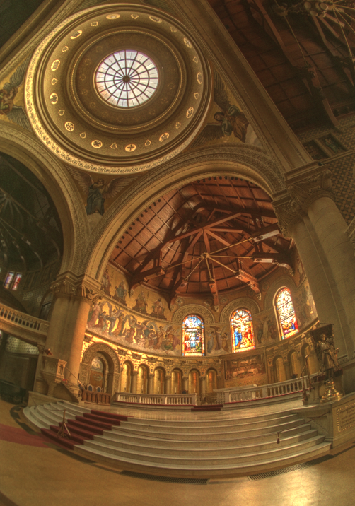

Local tone-mapped

By comparing the results of local and global tone mapping, we can see that more details are present in the local tone-mapped output than global tone-mapped output. Also the details in the darker regions are better visible in local tone-mapped image.

**Reconstruction of images using camera response function from the Office set of images:**

1. **Office:**

Alpha = 0.5

Alpha = 1

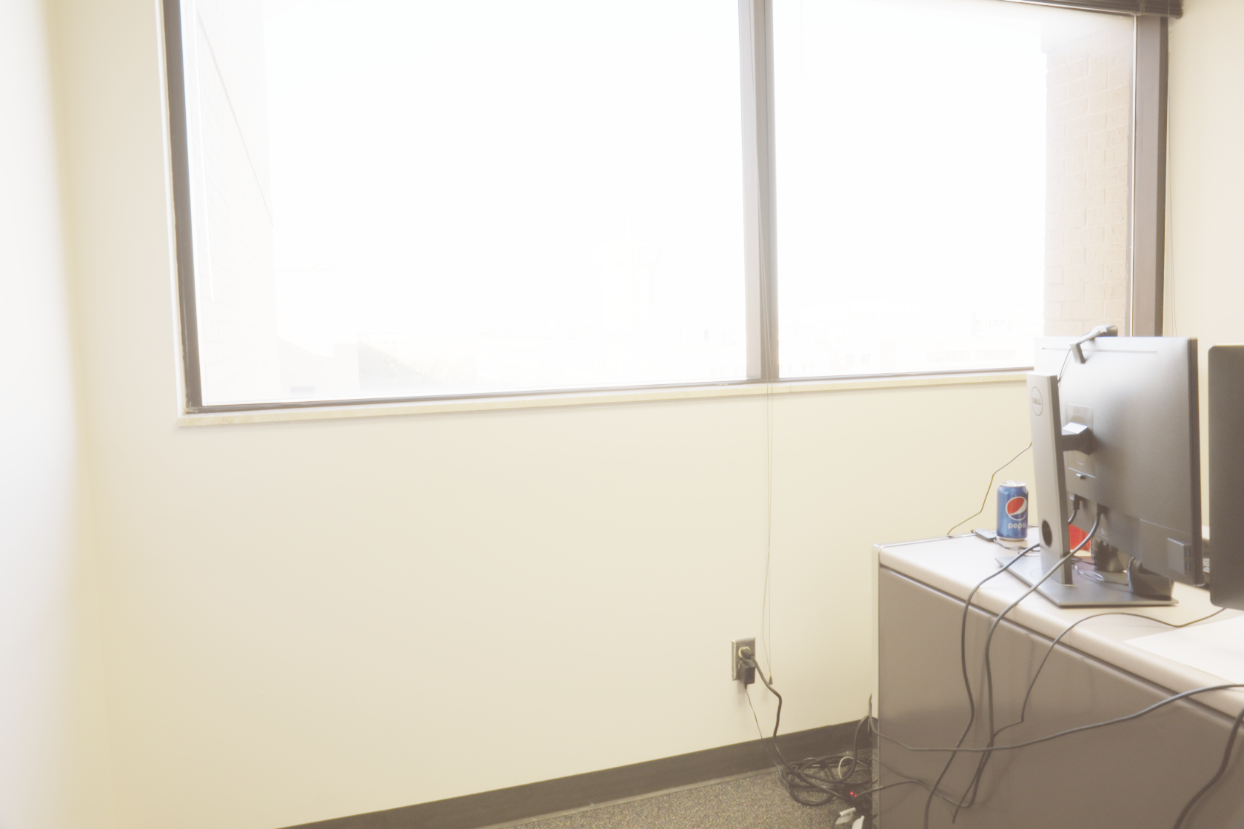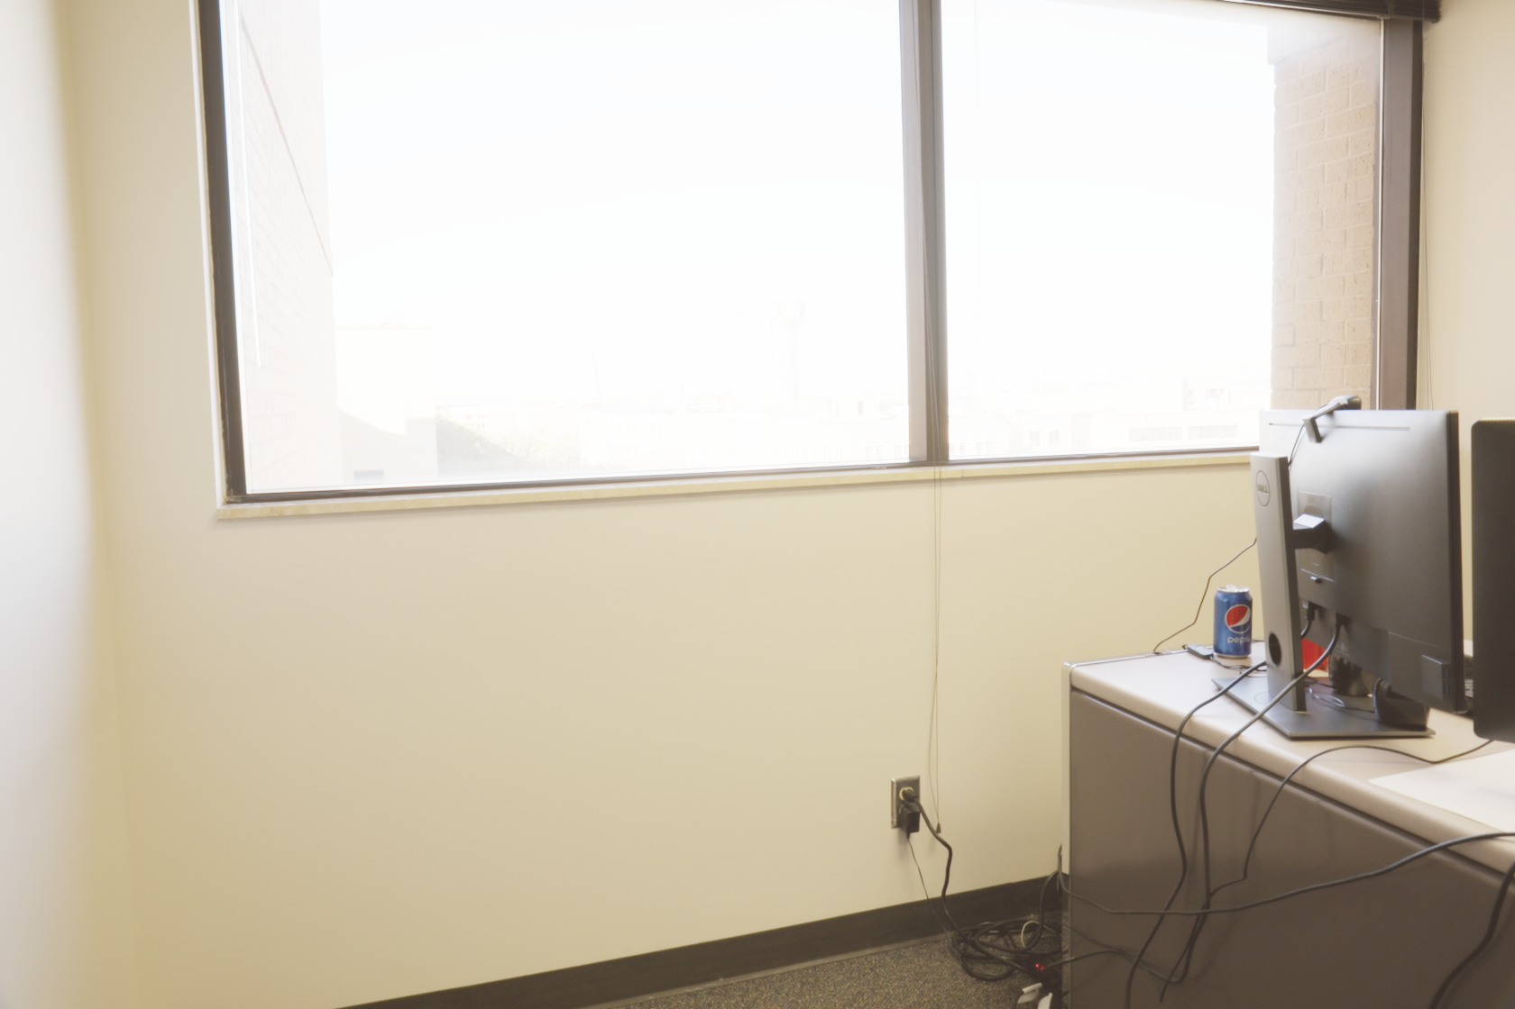

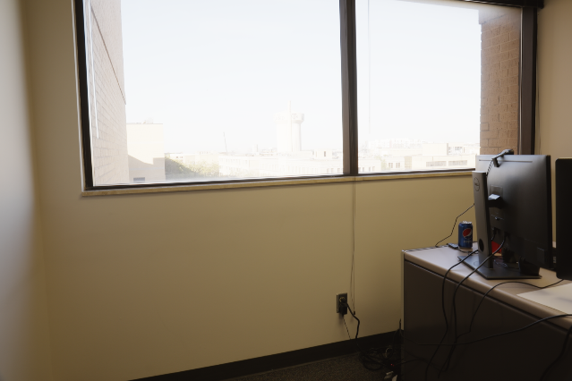

Alpha =0.05 0..050.05

Alpha = 0.1

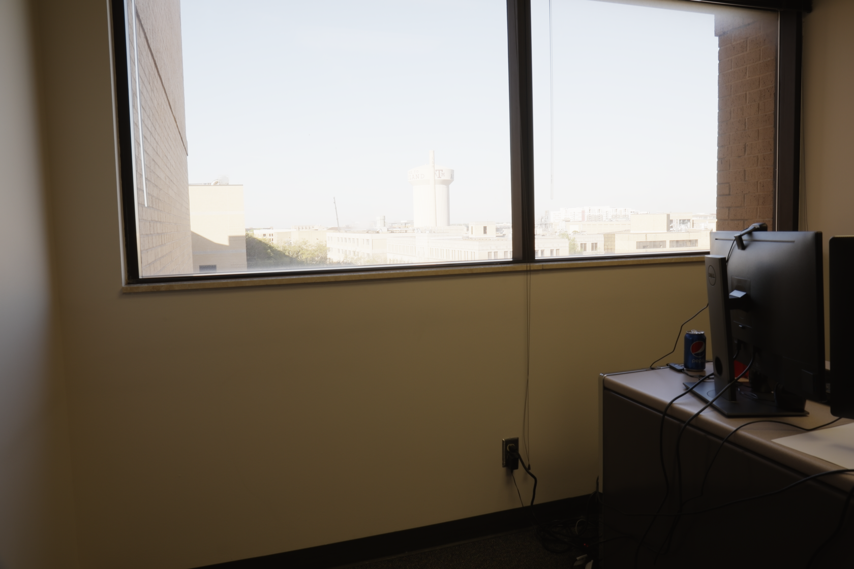

Alpha = 0.025

Alpha = 0.01

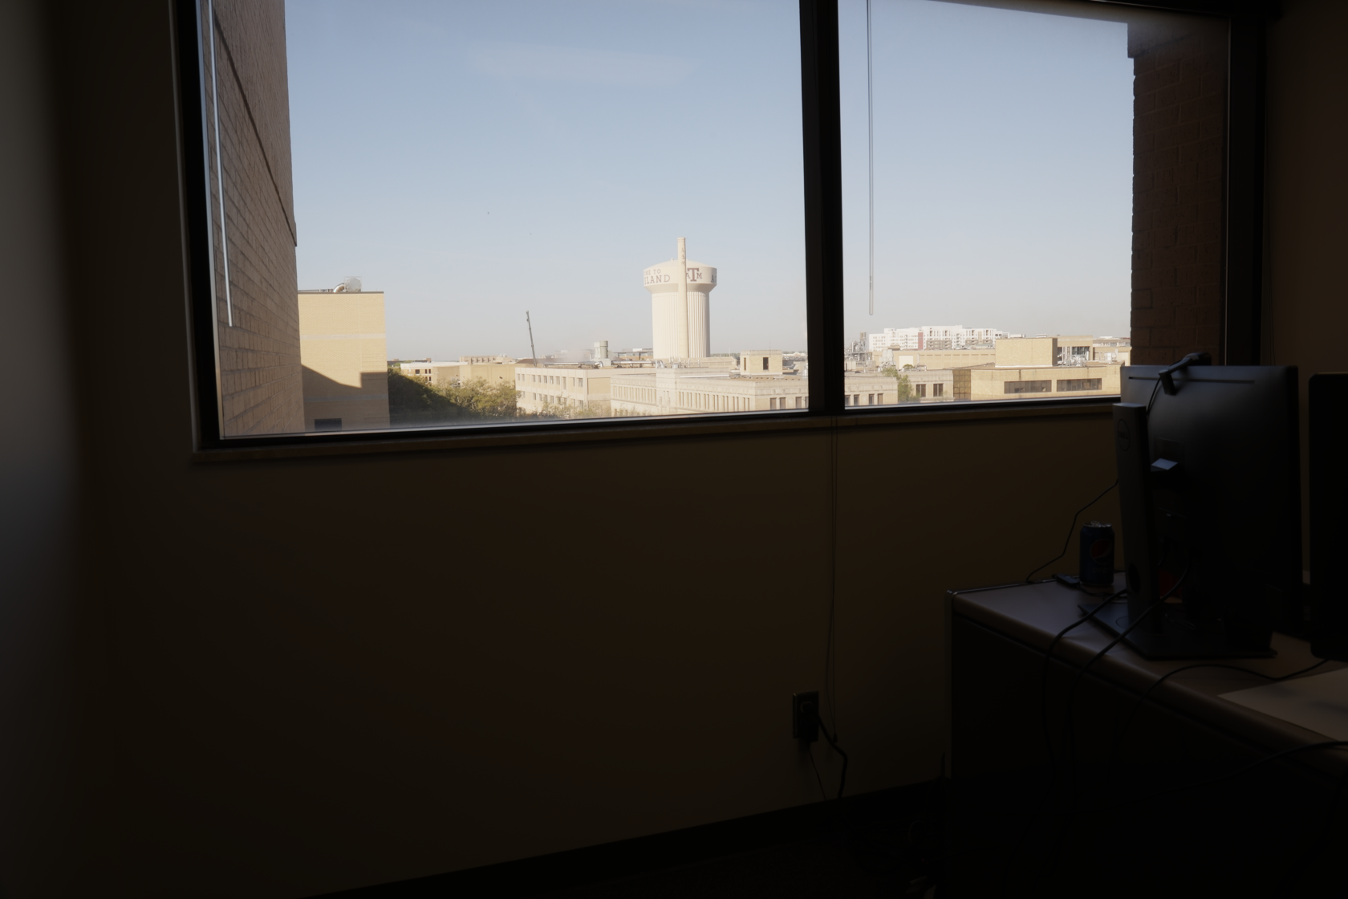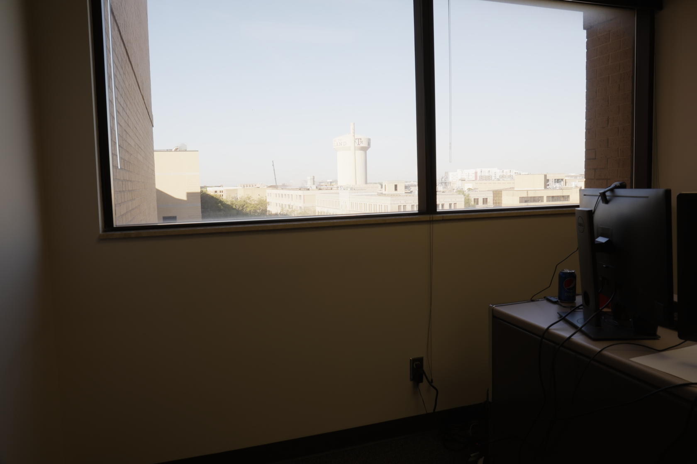

Local tone-mapped

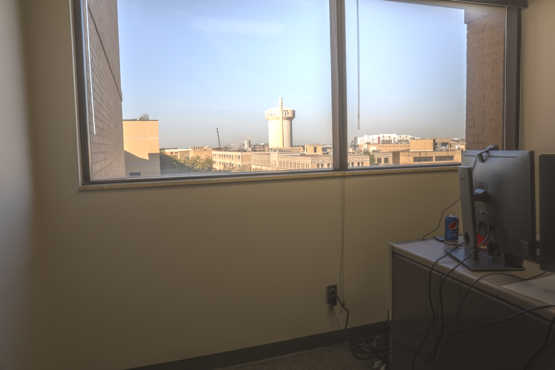

1. **Bicycles:**

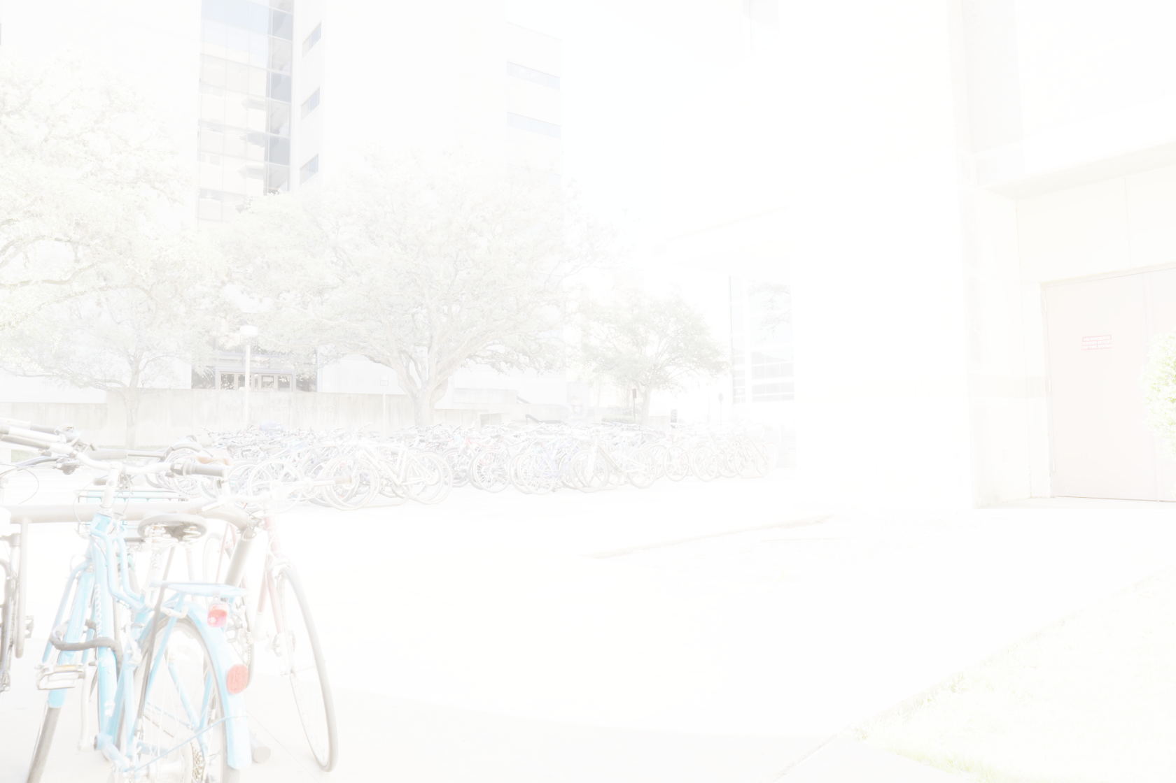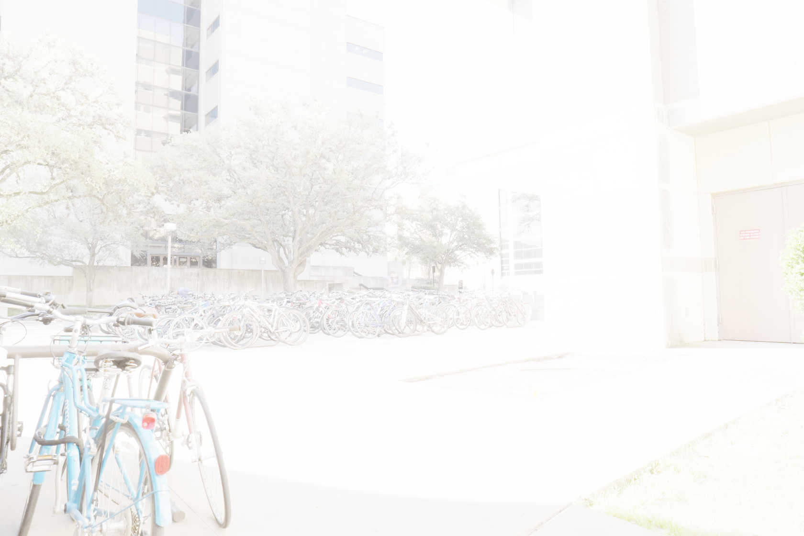

Alpha = 0.5

Alpha = 1

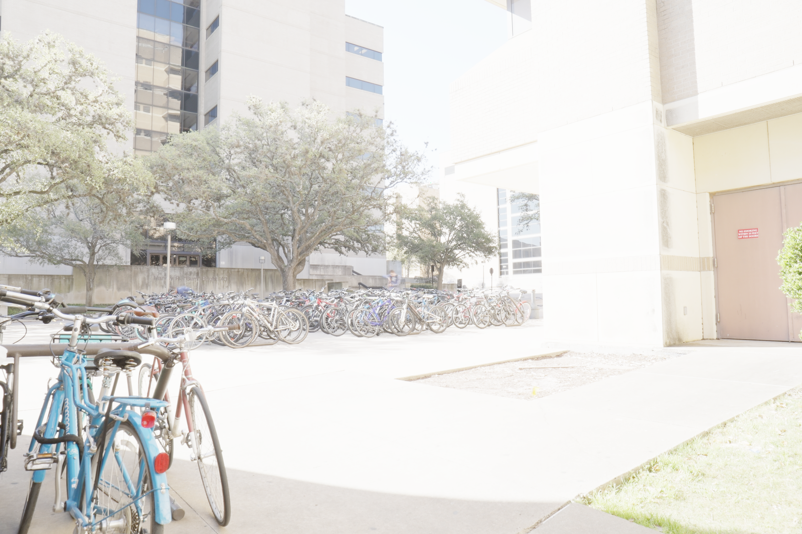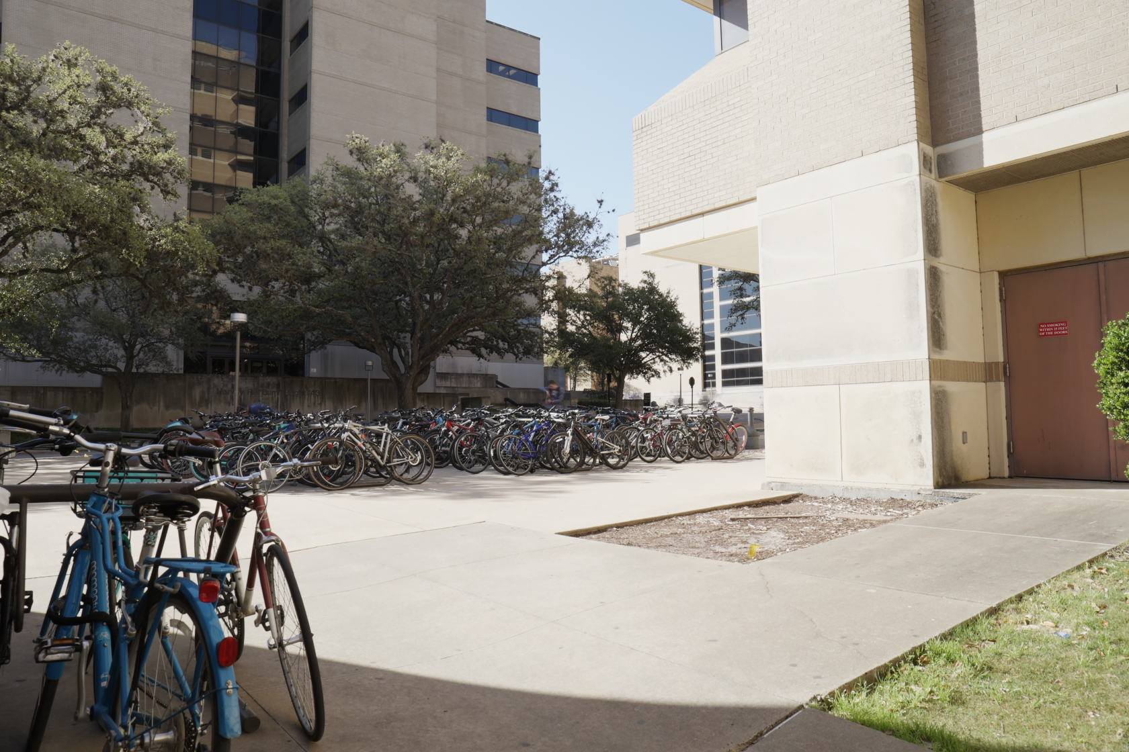

Alpha = 0.1

Alpha = 0.01

Local tone-mapped

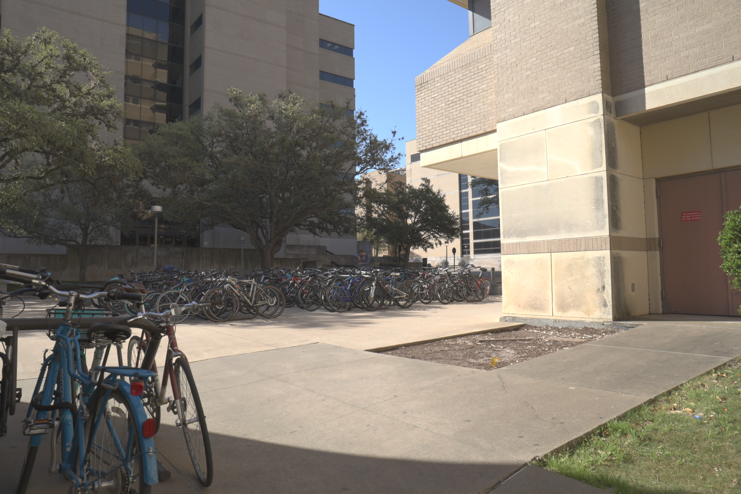

1. **Statue**

Alpha = 1

Alpha = 0.5

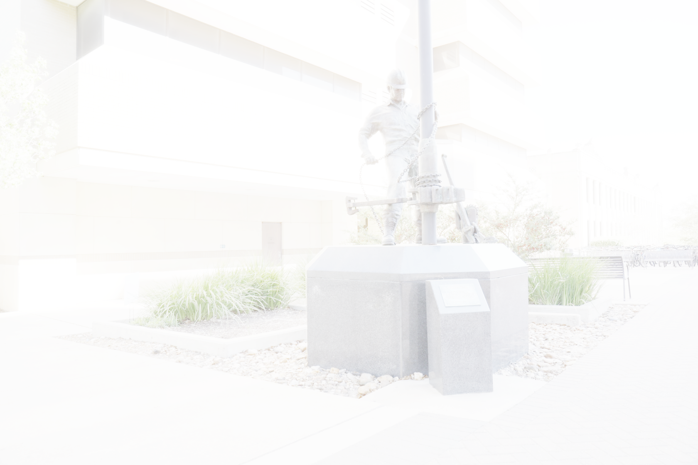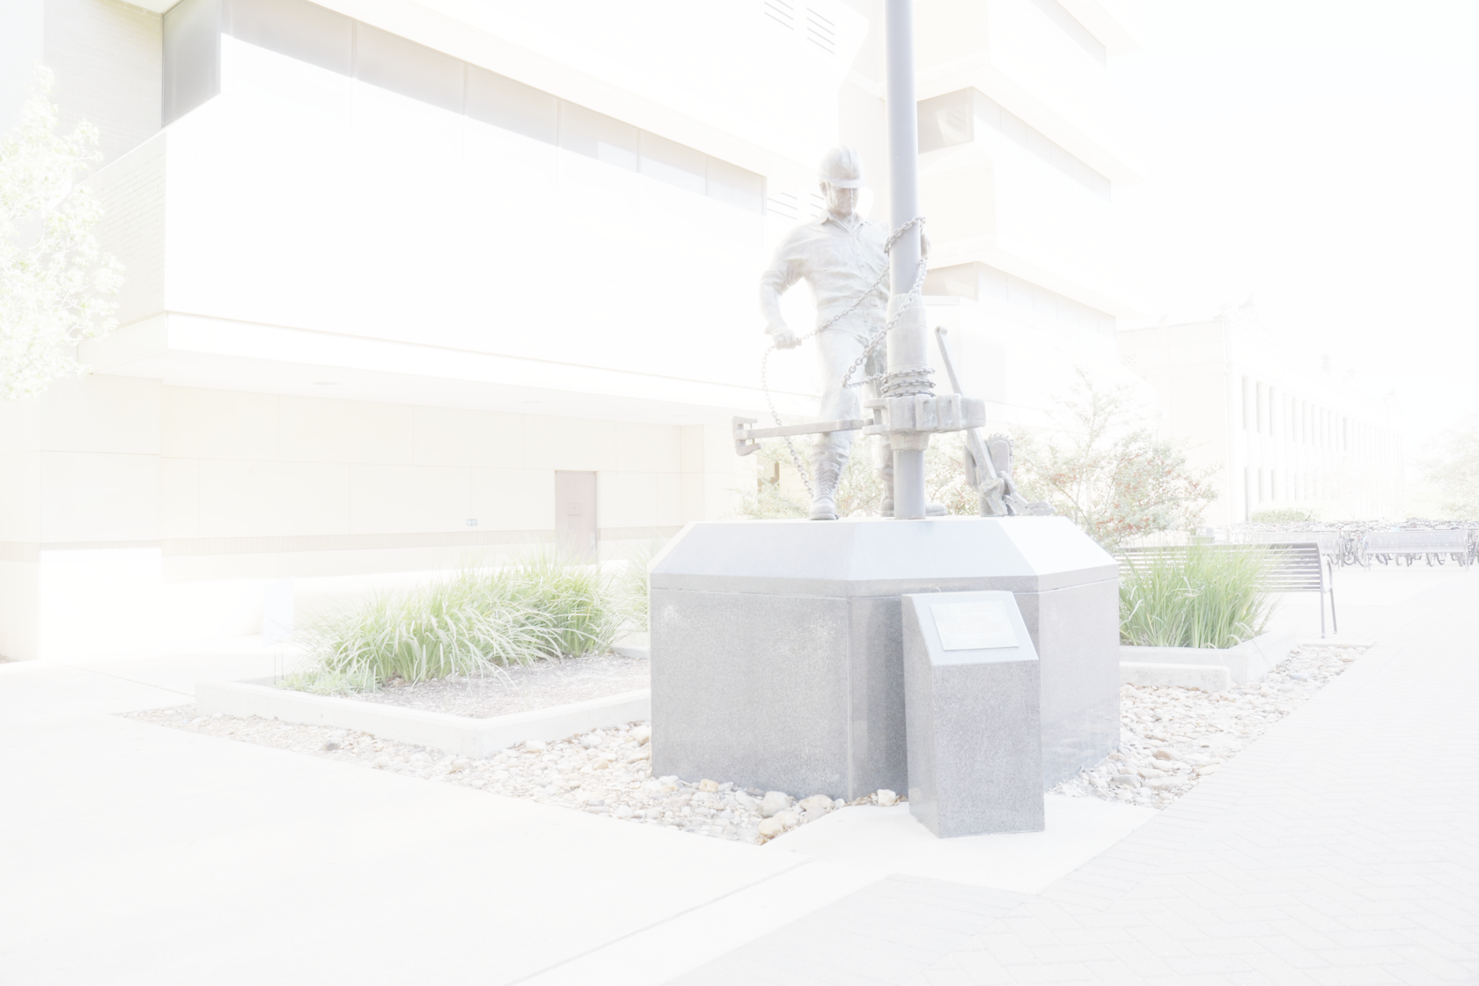

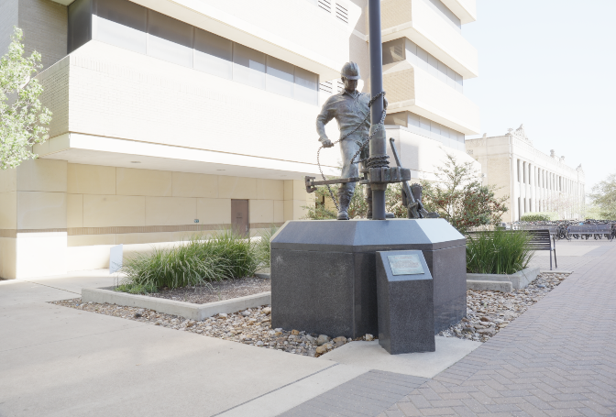

Alpha = 0.1

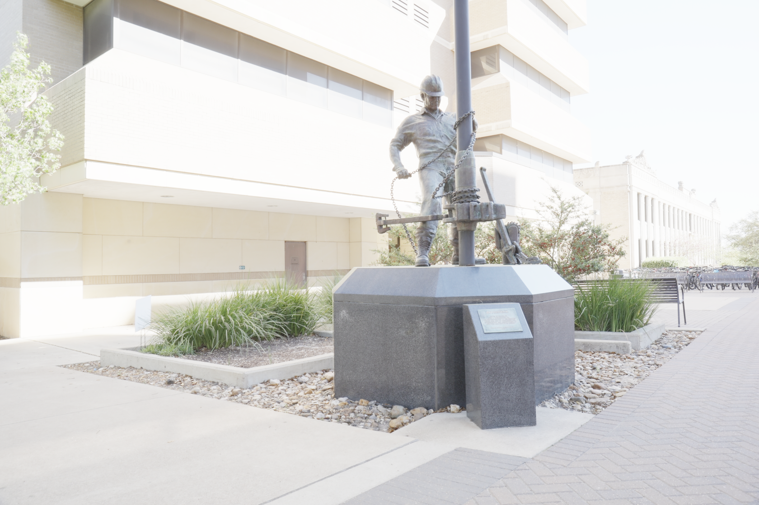

Alpha = 0.05

Local tone-mapped

Alpha = 0.01

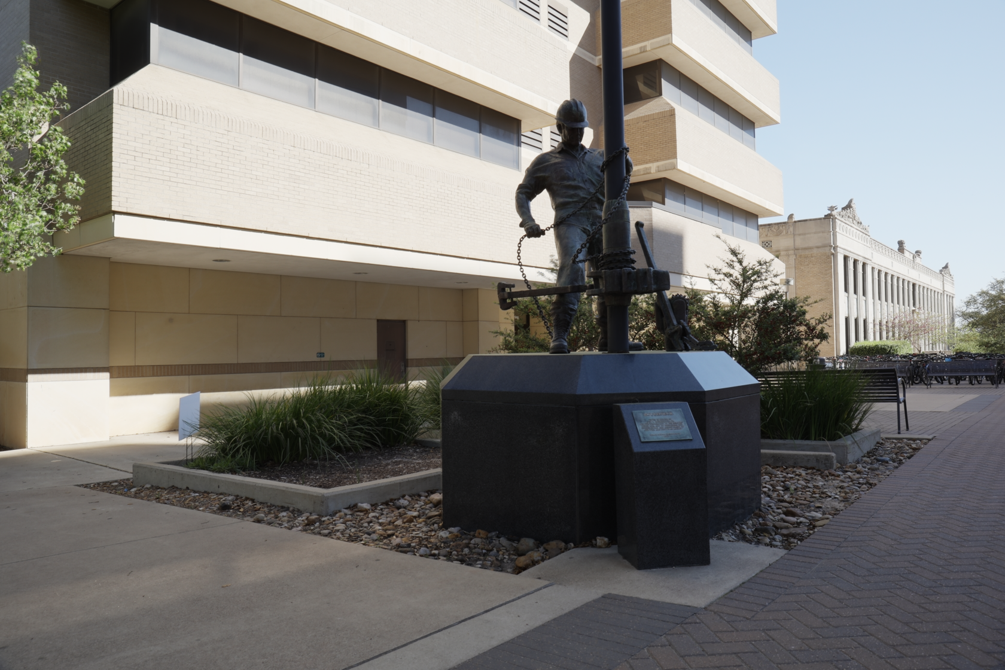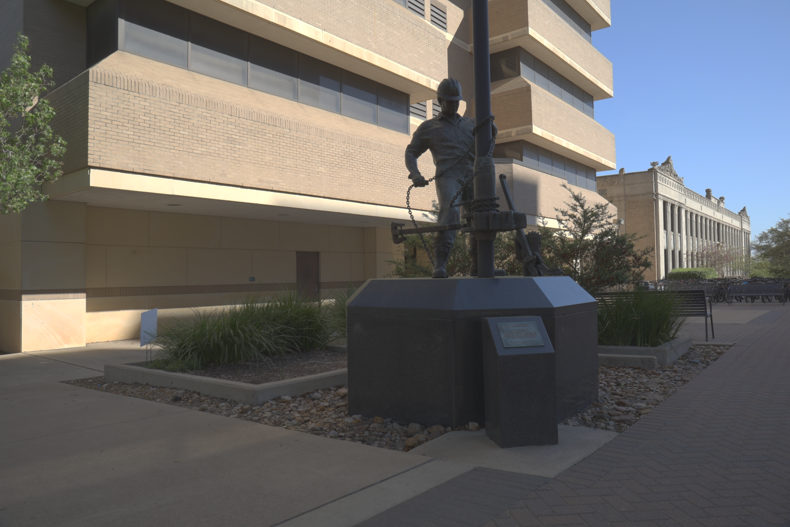

From all the images above we can see that there are more details in both the high illumination and low illumination areas. Using the second camera response function we can see that alpha in the range of 0.01-0.05 gave results with acceptable details in all illuminations.

We can also see that there is more contrast in the locally tone mapped images as the global tone-mapped images consider the whole image and the local tone mapped images consider only a specific region.

**Reconstruction of Chapel using the Camera Response Function from Office set of Images:**

Local Tone-mapped

Global Tone-mapped (alpha = 1)

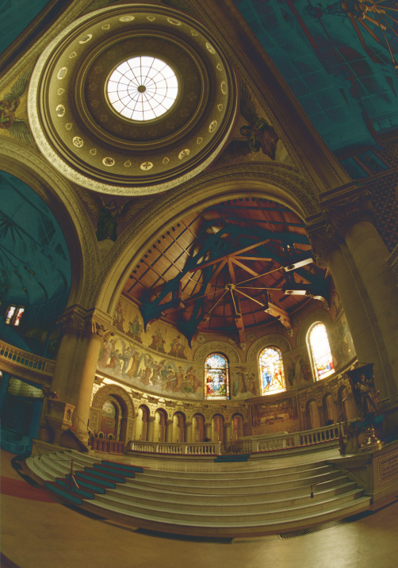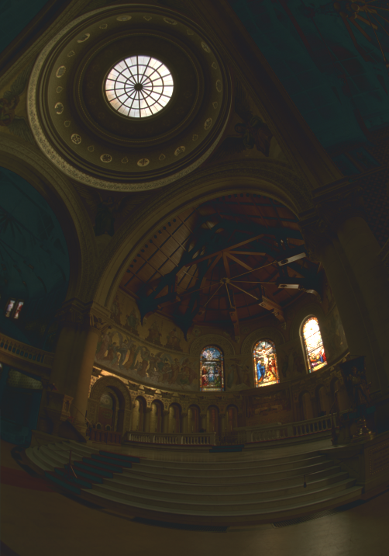

By using the other camera response function we can see that in the local brightness of the reconstructed images has reduced and the images have blueish tint. The reason for this that second set of images consist of a lot of pixels with blue in it which would have its effect on the camera response function. Thus this reflects in the reconstructed images in the form of bluish tint.